Gr.I.Ch.Oscar Romeo Wonderful Elite (a) | W.Ch.Florizel Magia Vostoka (b) | Selen Magia Vostoka (d)
 |  | W.Ch.Magic Thai Goblin's Greta
 | I.Ch.Mia Estet (a) | Edelweiss Stakkard (n)
 |  | Ch.Miriam Sanchitos (n) 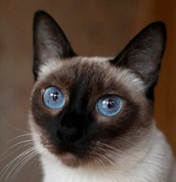
Gr.I.Ch.Moroshka Regal Splendor (b) | I.Ch.Zeppelin Regal Splendor (n) | Gr.I.Ch.Aivengo Thai Way (b) 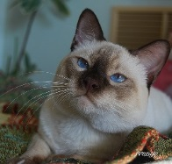
 |  | Gr.E.Ch Kamimisubie Thai Star 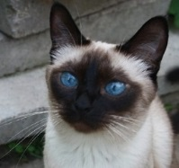
 | Frangipani Regal Splendor | Abigail (b)
 |  | Elinka Regal Splendor (n) 